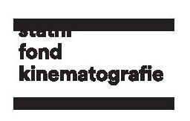

Czech films at Cannes Film Festival 2018

Prestigious Cannes Film Festival (8 - 19 May 2018) is just around the corner, and several Czech films are included in its program. Polis-Czech-Swedish co-production Fugue by Agnieszka Smoczyńska was selected for Semaine de la Critique and Cannes Classics will show digitally restored Diamonds of the Night by Jan Němec. In addition, Radovan Síbrt is this year’s Czech Producer on the Move. The Czech Film Fund and its divisions the Czech Film Center and the Czech Film Commission will as usual represent Czech film industry at the Marché du film in the Czech & Slovak Pavilion (131) at Village International. Moreover, three Czech films will be screened at market.
FUGUE (directed by Agnieszka Smoczynka) at Semaine de la Critique
The psychological thriller depicts the story of Alicia who has rebuilt a free-spirited way of life in the sake of a memory loss. Two years later she returns to her family, against her will, to take on her role as wife, mother and daughter. However, her husband and son do not recognize a woman looking familiar but acting like a stranger. Feelings of alienation, love and revelations will spark Alicia's inner flame.
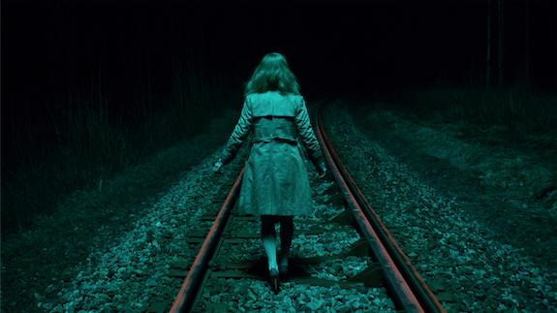
„Fugue is about the social taboo concerning motherhood and women socially pressured to accept this role without hesitation. What if it isn´t always the case? What if a woman had a possibility to forget about giving birth, having a child? Would she choose it again?” asks Smoczyńska.
The feature was supported by the Czech Film Fund with the amount of 100 000 EUR. Another financial support was provided for example by the Polish Film Institute, Eurimages, Odra-Film, the Mazovia Warsaw Film Commission, the Lower Silesia Film Fund, the funds of the City of Wroclaw and the Lower Silesia Region, MagicLab, and Film i Väst. The main producer is Agnieszka Kurzydlo from Polish MD4 with Karla Stojáková from Czech company Axman Production and Jonas Kellagher, from Swedish CommonGround Pictures, acting as co-producers. The international sales are handled by Alpha Violet.
„Fuga is a „female“ film. I was enthused not only by the screenplay and approach of the producer Agnieszka Kurzydlo, but also by the very talented director Agniszka Smoczyńska. I enjoyed the cooperation from the very beginning until the joyful news that the film was selected for Semaine de la Critique. It was the climax of the difficult journey of this film,” recounts Karla Stojáková. „The film was partially shot in the Czech Republic along with Czech music composer Filip Míšek and Czech VFX supervisor Michal Křeček from Magiclab, where the visual post-production of this film is being made.“

Diamonds of the Night in Cannes Classics
A newly restored version of the debut by director Jan Němec, “enfant terrible” of the Czechoslovak New Wave, Diamonds of the Night will be screened in the prestigious Cannes Classics showcase. The film was restored by the National Film Archive.
An existential drama of two Jewish boys who escape from a train transporting them from one concentration camp to another. Ultimately they are hunted down by a group of old, armed home-guard members. The film goes beyond the themes of war and anti-Nazism and concerns itself with man’s struggle to preserve human dignity. It became one of the first Czechoslovak New Wave films to receive an internationally recognized award, the Grand Prix at the International Film Festival Mannheim-Heidelberg in 1964.
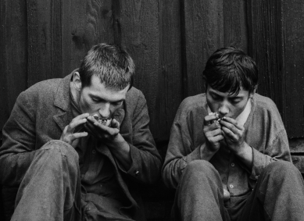
„The image was digitized from original negative on Agfa and Kodak film stock in 4K. Missing parts were substituted from duplicate positive. The source of the sound was the sound negative. The goal of digital restoration was to make the film available in a form similar to how it could have been seen by an audience at the time when it was first released in 1964. As a result, various features that originate from the shooting of the film or its laboratory processing have been preserved and are evidence of the technologies and creative approaches of the time. Vintage print on Agfa film stock was selected as a reference for color corrections. Tonality of the digitally restored film is based on this print originating from the time when the film was released for the first time,” says Tereza Frodlová from National Film Archive who was in charge of the digitization.
It is a second Czechoslovak film restored by NFA to be screened at Cannes Film Festival. In 2016, the sci-fi film Ikarie XB 1 by Jindřich Polák (1963), which inspired the director Stanley Kubrick to shoot the cult film 2001: Space Odyssey, was included at Cannes Classics.

Tribute to Miloš Forman in Cannes
The festival will pay tribute to famous director Miloš Forman, who recently passed away, on the opening day at the Cinema de la Plage. It has been 50 years since his film comedy The Firemen‘ s Ball took part in the main competition of Cannes Film Festival in 1968, whose then 21st edition was prematurely terminated due to the turbulent political development in France.

Czech & Slovak Pavilion in Cannes and the Czech Film Fund
The Czech Film Fund and its divisions the Czech Film Center and the Czech Film Commission will once more represent Czech cinema and film industry at the Czech & Slovak Pavilion No. 131 at Marché du Film.
Moreover, three films with Czech participation - animated Harvie and the Magic Museum (Martin Kotík, Inna Evlannikova), the winning film of this year's Berlinale shot in Czech co-production Touch Me Not, and Slovak-Czech Interpreter (Martin Šulík) will be screened at Marché du Film.

Producers on the Move: Radovan Síbrt
the 19th edition of European Film Promotion’s Producers on the Move will take place in the frame of festival. Czech producer Radovan Síbrt (Touch Me Not, When the War Comes) was selected among 20 European producers to take part in this event.
Radovan Síbrt (1975) graduated at Faculty of Arts, Charles University and Department of Direction at Film and TV School of Academy of Performing Arts in Prague. He co-founded along with Alžběta Karásková the production company PINK in 2010. Síbrt co-produced the Berlinale-winning feature, psychological drama Touch Me Not (2018) by Romanian director Adina Pintilie. Another film produced by Síbrt is When the War Comes (Jan Gebert, 2018), which was also screened at this year’s Berlinale.
In the past, for example, Pavla Janoušková Kubečková, Jan Macola, Tomáš Hrubý, Viktor Tauš, Radim Procházka, Jiří Konečný, etc. participated in this program.

Doc Alliance Goes to Cannes
Doc Alliance will participate this year in Goes to Cannes program and the Czech-Slovak project Dubček: All Men Become Brothers (d. Robert Kirchhoff), nominated by Jihlava IDFF produced by Jiří Konečný (endorfilm) will be presented among five documentaries in post-production.

CONTACTS

Czech Film Fund / Czech Film Center

Helena Sedmidubská
Editor & External Communication
helena@filmcenter.cz
+420 777 501 562
www.filmcenter.cz

