Press release. Prague, 14th September, 2017

Czech film Who's Who in Mycology received a Student Academy Award
The fifteen-minute short film Who's Who in Mycology by young talent Marie Dvořáková has been awarded by the American Academy as one of the three winners in the narrative film category (domestic film schools) in the frame of 2017 Student Academy Awards.

The Academy has voted 17 students as winners of the 44th Student Academy Awards® competition. This year, the Student Academy Awards competition received a total of 1,587 entries from 267 domestic and 89 international colleges and universities – which were voted by a record number of Academy members. The 2017 winners join the ranks of such past Student Academy Award winners as Patricia Cardoso, Pete Docter, Cary Fukunaga, John Lasseter, Spike Lee, Trey Parker and Robert Zemeckis. See full list of winners HERE.
Marie Dvořáková is the second Czech winner of the prize, after Jan Svěrák, awarded in 1989 for his short Oil Gobblers. The movie is part of Czech Short collection, selected every year by Czech Film Center to promote Czech short films worldwide.

Who’s Who in Mycology is Marie Dvořáková’s graduate film at the NYU Tisch School of the Arts. The film was shot in Czech-US coproduction with Negativ Film Production and Czech Televison producing on the Czech side and it was supported by the Czech Film Fund. Czech producers are Marie Dvořáková, Marta Kuchynková, and Milan Kuchynka, script was written by Dvořáková, Micah Schaffer, and Tony Hendra. Cast: Joel Brady, Johana Schmidtmajerová and others.
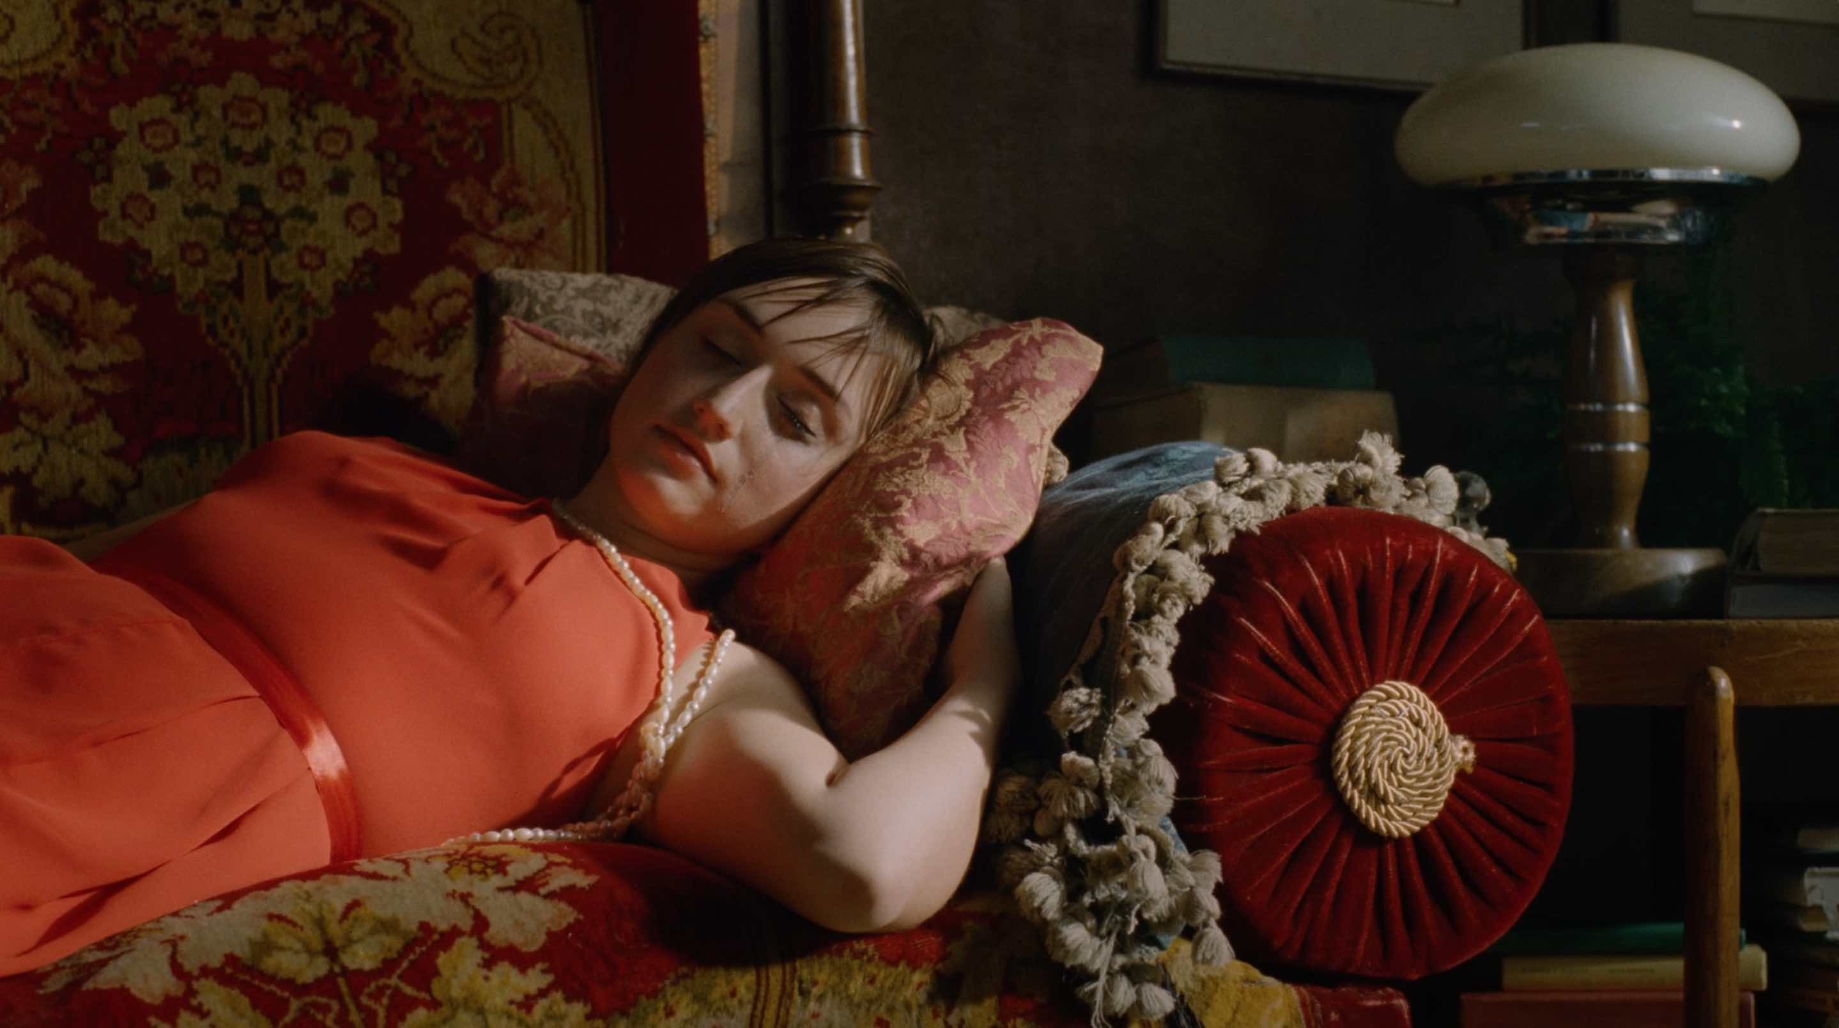
Who's Who in Mycology is a story of
a young trombone player who spends an adventurous night trying to open an impossible bottle of wine. An unconscious girl, a crooked bookcase, and some mold get in his way, turning his world upside down. When the night is over he is forced to commit the ultimate act of courage.
"Already as a child I've been fascinated by movies that used film tricks and illusions to create a spectacle for the audience. I wanted to tell a story that takes place in a small room, but it is the greatest adventure that one can imagine," says Dvořáková.
Marie Dvořáková is a graduate of the Prague Film School, FAMU, now continuing her studies at the NYU Tisch School of the Arts. Her narrative and documentary short films were screened and have received awards at several film festivals worldwide. In addition, Marie is the recipient of the 16th Annual Student Filmmakers Award of the Directors Guild of America. She is also the 2011 Spike Lee Production Fund Award recipient and received the 2010 Sloan Film Production Grant as well as
a production grant from the Jerome Foundation. Her work was shortlisted for the AICP Awards in New York and for the 2010 Cannes Young Director Award. She received the World Bronze Medal at the 2010 International Advertising Awards in Shanghai, and the 1st Prize at the 2010 Porsche Awards in Germany.
“For over a year I was collecting 35mm short ends in Europe and the US, because we couldn’t afford to buy new film stock,” says Dvořáková. “My stock was two years expired, but for me shooting on film was essential. Most of the short ends purchased for a very low price came from Ridley Scott’s production of Child 44 that was shot in Prague some years ago. Other short ends were given to me in the US. That meant whoever from my family and among my friends traveled to NYC had to carry an extra suitcase, pick up cans with old film, and bring them back to Prague where the movie was shot.“
Synopsis:
Tony, a young trombone player in a brass band, leads a humdrum life. He plays the same music over and over every night. But this night will turn out to be special. While playing his solo, a tipsy female dancer collapses on the dance floor. Tony ends up taking her home. After he drops her on the sofa in her shabby living room he needs a drink. He doesn’t pay attention to the weird mold stains on the walls, or to the large crooked bookcase stuffed with hundreds of books with the same title. All he cares for is to find a corkscrew and open the bottle of wine standing on the table. Once he does, his life turns upside down. When the night is over he is forced to commit the ultimate act of courage.
http://www.filmcenter.cz/en/news/1306-who-s-who-in-mycology-received-a-student-academy-award

Hedvika Petrželková
Editor&vnější komunikace / Editor&External Communication
Czech Film Center
____________________________
Národní 28, 110 00 Praha 1
mobile: +420 770 127 726
e-mail: hedvika@filmcenter.cz
www.filmcenter.cz
facebook

Press servis:
Hedvika Petrželková
Czech Film Center
Národní 28, 110 00 Praha 1
+420 770 127 726, +420 776 167 567
hedvika@filmcenter.cz
www.filmcenter.cz; facebook

