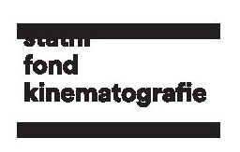
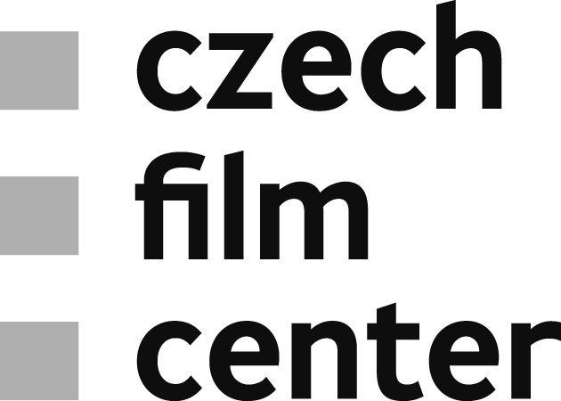

Prague, June 5th 2018
Strong presence of Czech films and co-productions
at Karlovy Vary International Film Festival
53rd Karlovy Vary International Film Festival has announced its competition line-up. This year, the selection includes a record number of 12 Czech and co-production movies that will have their world premiere at the festival. Three Czech films – a road movie Winter Flies by Olmo Omerzu, Adam Sedlák’s feature debut Domestique and a minority Czech co-production “I Do Not Care If We Go Down In History As Barbarians” by Romanian filmmaker Radu Jude – will try their luck in the main competition section. The East of the West competition includes the debut Moments (d. Beata Parkanová), Bear with Us (d. Tomáš Pavlíček) and minority co-production Via Carpatia by Klara Kochańska. Tomáš Bojar's Breaking News, Jana Andert’s Inside Mosul and Putin’s Witnesses by Vitaly Mansky, shot again in the Czech co-production, were selected for the documentary competition. Finally, Benjamin Tuček’s sci-fi comedy Trash on Mars will be presented out of competition and two documentaries King Skate by Šimon Šafránek and Michal Varga’s Circus Rwanda will be part of non-competitive Special Events section.
Czech-based, Slovenian-born Olmo Omerzu will present his road movie Winter Flies about two boys who set out into the frozen wastes in search of adventure. The film was produced by Jiří Konečný (endorfilm) and supported by the Czech Film Fund with €367,450. Adam Sedlák‘s feature-length debut Domestique is also Jakub Jíra’s production debut (ShorePoints). The story is centred around the bicycle racer who is willing to sacrifice everything for the team including his wife Šarlota. Domestique has garnered €97,000 in support from the Czech Film Fund. Romanian director Radu Jude’s new film “I Do Not Care If We Go Down In History As Barbarians” unfolds the national trauma from the World War II. The film was coproduced by Romania, the Czech Republic, France, Bulgaria, and Germany, and was supported by the Czech Film Fund as a minority co-production with €156,863. It is the second cooperation between Czech producer Jiří Konečný (endorfilm), Romanian producer Ada Solomon (Hi Film Productions) and director Radu Jude.
The East of the West Competition section includes three films with Czech footprint. Beata Parkanová’s debut Moments depicts the story of Anežka whose life seems not to belong to her anymore, as her entire family wants to get involved in every aspect of it. The film was supported by the Czech Film Fund with €168,235 and was produced by Viktor Tauš (HEAVEN’S GATE). Tomáš Pavlíček’s Bear with Us – a comedy about a family who gather in their country cottage for the last night before it’s sold. The Czech Film Fund supported Bear with Us, produced by Tomáš Michálek and Jakub Mahler (MasterFilm), with €272,941. The third film selected for the competition is Klara Kochańska’s feature-length debut Via Carpatia, which was shot in Polish-Czech-Macedonian co-production with the Czech producer being again Viktor Tauš (HEAVEN’S GATE).
The documentary competition will also present three Czech films. Tomáš Bojar's Breaking News observes two newsrooms during Czech president’s decision whether to run or not for re-election. The feature has garnered €37,255 support from the Czech Film Fund and was produced by Tomáš Bojar’s Cinema Arsenal. In a war documentary Inside Mosul, Jana Andert for eight months filmed the elite unit of the Iraqi Army in the first battle line. The Czech Film Fund supported the film produced by Jan Macola (Mimesis Film) with €19,608. The latest work filmed by previous Karlovy Vary winner Vitaly Mansky, Putin’s Witnesses, takes a fascinating look at the presidential career of Vladimir Putin. Co-produced by Filip Remunda and Vít Klusák (Hypermarket Film), the film was also supported by the Czech Film Fund with €39,216.
In addition to the Czech films in the competition sections, the festival gives a special space to three more films. Benjamin Tuček’s sci-fi comedy Trash on Mars, which was shot in a simulated space station facility in the desert of Utah, will have its world premiere out of competition. Two documentaries, King Skate by Šimon Šafránek, produced by Negativ, and Michal Varga’s Circus Rwanda, produced by Xova Film, will be both presented as Special Events at the festival. They were also supported by Czech Film Fund - King Skate with an amount of €58,824 and Circus Rwanda received €56,863.
Moreover, a selection of ten Czech films from the past year will be shown in the non-competitive section Czech Films 2017-2018, including Jan Švankmajer’s Insect, Martin Šulík’s The Interpreter, Jakub Šmíd’s Short Cut or the documentaries Nothing Like Before by Lukáš Kokeš and Klára Tasovská or When the War Comes by Jan Gebert. Several other Czech new films as well as some Czechoslovak restored classics will be presented in other sections of the festival.
Lastly, this year’s 53rd edition of the Karlovy Vary International Festival will honour the memory of the recently deceased Miloš Forman at its opening Ceremony. The opening film of this year's festival will be Forman’s legendary comedy Loves of a Blonde (1965). Music from Miloš Forman’s films, such as Loves of a Blonde, Taking Off, Valmont, Amadeus or Hair will be performed by the Czech National Symphony Orchestra during the opening concert, following the ceremony on June 29th.

